Requirement Analysis

And

Usability Report

(Website Development)

Members:

Mubashir Zulfiqar (leader)

021-18-44917

Iqra University Student (Main Campus)

Mubashir.44917@gmail.com

Hammad-Ur-Rehman Muhammad Umar

021-18-43928 021-18-44998

Iqra University Student Iqra University Student

(Main Campus) (Main Campus)

[Hammadahsan83@gmail.com](mailto:Hammadahsan83@gmail.com) [Muhammad.umar.umeri@gmail.com](mailto:Muhammad.umar.umeri@gmail.com)

Requirement Analysis:

Functional/Non-Functional Requirements:

The functional requirements of our project are that a user can do shopping at ease, without going in trouble of having to go in crowded markets and do a lot of search instead he can use our project (E-Commerce website) to go on an online shopping store and buy the things he wants to without any hassle. And the order will be delivered at his door step. A user can login/signup into the website by entering desired information and then search for his desired products. He can add them directly to his cart or add them to his Wishlist for future purchases and then checkout from his cart by adding information about himself and delivery method. Admin can Add/Delete/Update products, categorize, taxes by an easy to use and user-friendly CMS. Admin can add new blogs and posts.

The non-functional requirements of our project (E-Commerce website) are that our website should be user friendly, Responsive and beautiful in design. On signing up a new secured password will be sent to the user through e-mail. All taxes (GST and other) should be calculated automatically at the checkout screen. User can choose between payment methods according to his desire. After order is placed a confirmation e-mail should be sent to the user with invoice and similarly on delivery. User can track his order by the order-id which will be sent along with the confirmation email.

Main Use Case Diagram: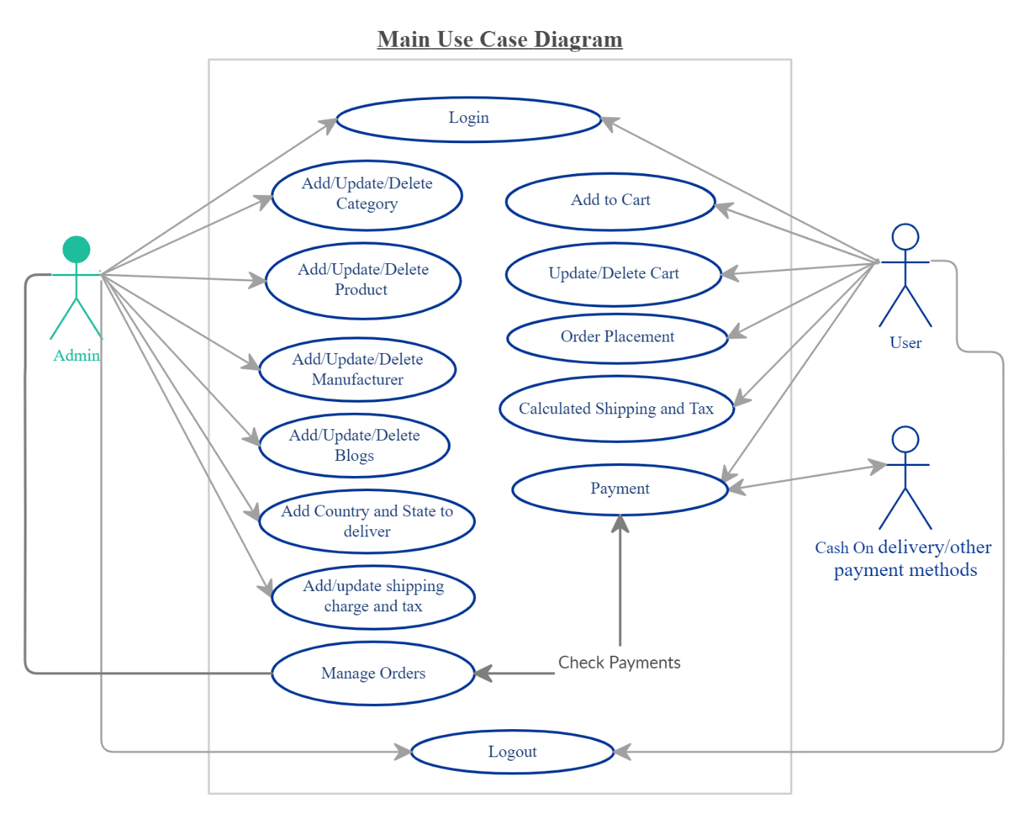

Sub Use cases with narratives:

* 1. login/Signup:

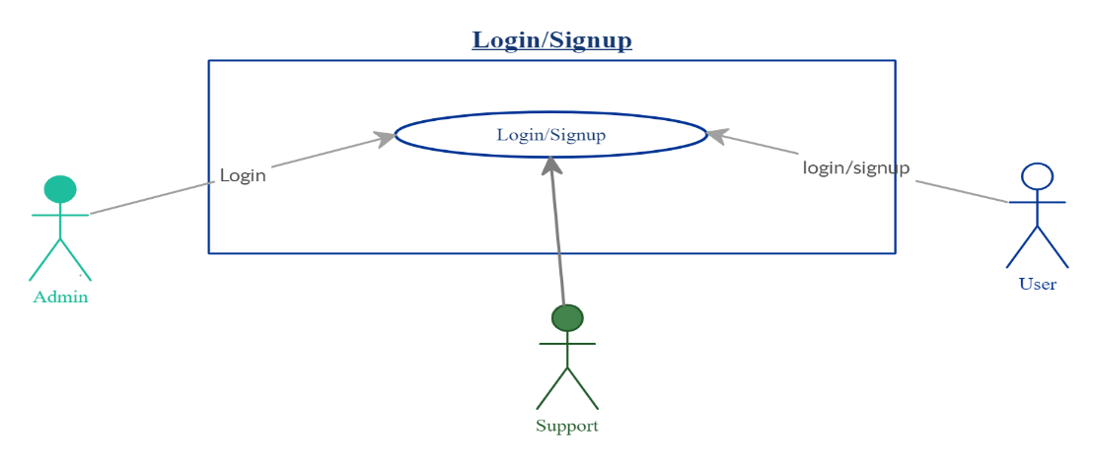

|  |  |  |
| --- | --- | --- |
| **Use Case Name:** | Login/Signup to the website. | |
| **ID:** | 01 | |
| **Actors Involved:** | Customer, Support, Administrator | |
| **Brief Description** | Actor enters the email address and password to login to the system. | |
| **Pre-Conditions** |  | |
| **Post-Conditions** |  | |
| **Normal Flow of Events:** | **Actor Action** | **System Response** |
| 1. Enter email address and password. 2. Clicks the submit button. | 1. System displays the actor dashboard page on successful login. 2. System displays error message on invalid login. |

* 1. Managing Orders:

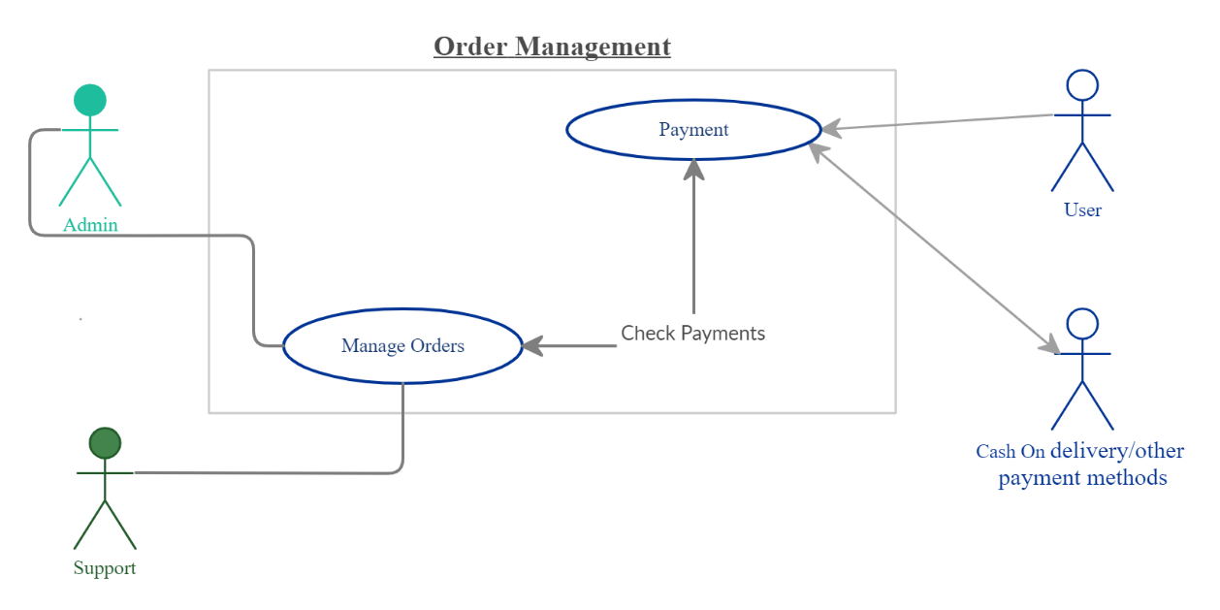

|  |  |  |
| --- | --- | --- |
| **Use Case Name:** | Managing Orders of Users | |
| **ID:** | 02 | |
| **Actors Involved:** | Support, Administrator | |
| **Brief Description** | User enters the products to purchase and then admin/support can manage orders | |
| **Pre-Conditions** |  | |
| **Post-Conditions** |  | |
| **Normal Flow of Events:** | **User Action** | **System Response** |
| 1. Enter products to purchase. 2. Clicks the checkout button. | 1. System displays the actor invoice on successful Purchase page. And send invoice and confirmation message on users’ email. 2. System displays error message on invalid. |

* 1. Website Maintenance:

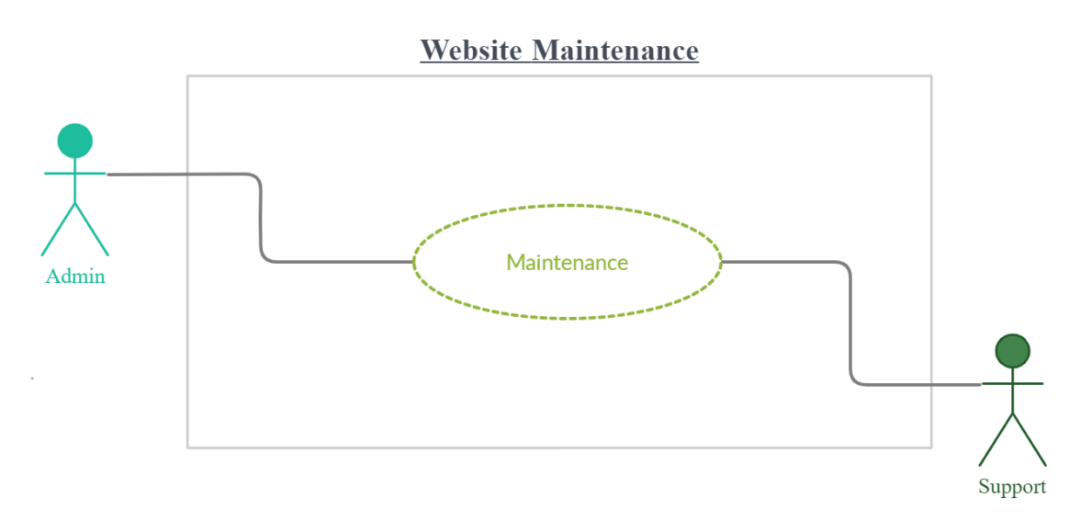

|  |  |  |
| --- | --- | --- |
| **Use Case Name:** | Maintaining Website | |
| **ID:** | 03 | |
| **Actors Involved:** | Support, Administrator | |
| **Brief Description** | Admin and Support can maintain the website through CMS. | |
| **Pre-Conditions** |  | |
| **Post-Conditions** |  | |
| **Normal Flow of Events:** | **User Action** | **System Response** |
| 1. Add/Update/Delete products. 2. Add/Update/Delete Categorizes. 3. Add/Update/Delete Blogs/Posts. 4. Add Update Taxes. | 1. System Add/Update/Delete products in website. 2. System Add/Update/Delete categorizes in website. 3. System Add/Update/Delete Blogs/Posts in website. 4. Add Update Taxes on the products in website. |

Prototype/Wireframe:

Homepage:

